Dual band network card U12: How to uninstall driver?
model: u12 question category: internet setup

Take windows 7 system for instance:
1.Open control panel and click “Uninstall a program” below the programs.
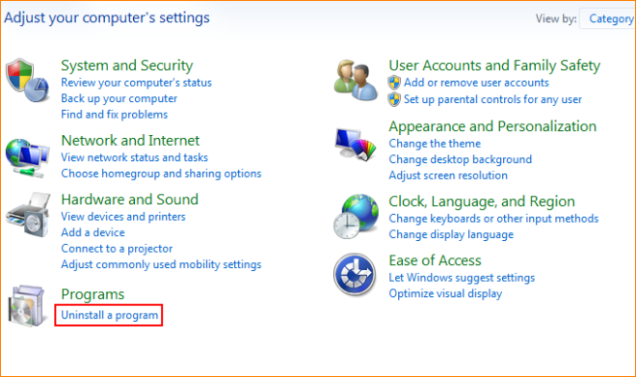
2.Find network card driver “Tenda Wireless Utility”, click “Uninstall”.
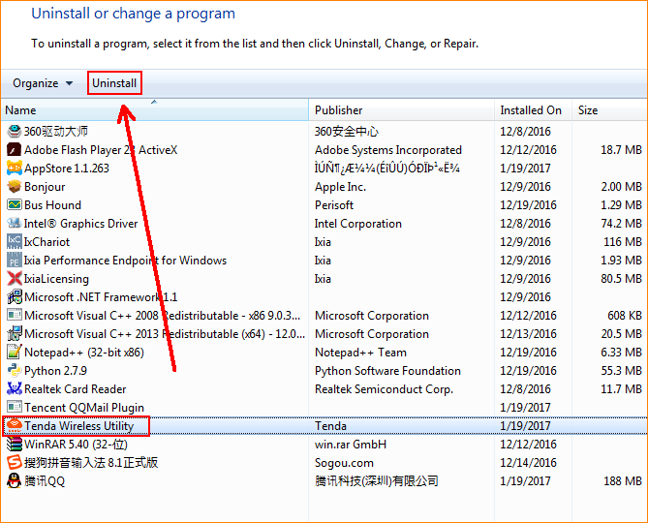
Click “Yes” and run uninstall program.
If you just want to uninstall User Interface of network card, you can cancel the tick of “Uninstall the driver”.
